Richfield Foundation
P.O. Box 23077
Richfield, MN 55423

Dear Community Group,
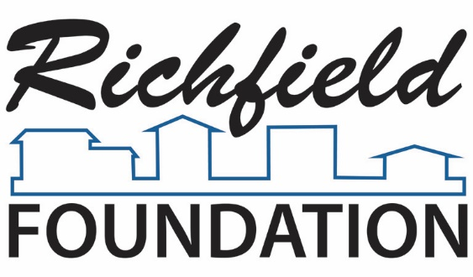
Chair
Scott Hvizdos

Vice-Chair
Isela Xitlali Gomez
Secretary
Rose Jost
Treasurer
Steve Schneeberger

Board of Directors
Hamuda Ahmed
Cathy Bender
David Brown
City Manager
Steve Devich
Kristin Eide
Pat Elliot
Claire Plank Gahler
Debbie Goettel
Susan Rosenberg
Liz Sanborn
Joanna Schnedler
Laura Sofia
Simon Trautmann
Ted Weidenbach
In 2014, the Richfield Foundation introduced a new Great Ideas Matching Grants opportunity, to match funds raised by smaller community-based groups running projects that benefit Richfield.
In 2018, applications will be accepted April 1 through July 31. Decisions will be made by the Foundation Grant Committee, usually within one month. Grants will be awarded in amounts up to $500.
The Great Ideas Matching Grants are in addition to our annual competitive grant-making process. This process will not change. Applications will be due in the fall and decisions made in November. It is highly unlikely that a group would get grants from both sources in the same year.
Both grant opportunities support the priorities of the Richfield Foundation: Successful kids – Secure Families – Strong Community
If you wish to apply for funds from the Foundation, please fill out the application and send it to: richfieldfoundation@gmail.com.
If you have any questions about the grant process, do not hesitate to call me at 612-203-9138 (cell) or 612-866-2683 (home).
If you cannot send the application electronically, mail to:
Susan Rosenberg
Richfield Foundation
6633 Thomas Ave. South
Richfield, MN 55423

Thank You,
Susan Rosenberg
Chair of the Grants Committee
Richfield Foundation

Who Should Apply for a Great Idea Matching
Grant from the Richfield Foundation?
This opportunity is designed for smaller organizations, which rely heavily on volunteers to carry out their work. Every organization or project must meet the criteria of benefiting people in Richfield and fit with our three stated priorities: Successful Kids-Secure Families-Strong Community. Projects should also fit the Foundation’s goal of getting more people involved in our community. Whether it is athletics, arts, academics, or basic human needs, we want to make it easier for people to participate fully in life in Richfield.
The Richfield Foundation created this fund to better meet the needs of small organizations serving Richfield. It has more specific criteria and smaller maximum amounts than the annual grant making process, but is available more of the year and has a shorter application process.
It is designed to encourage grassroots fundraising efforts. We want your fundraising efforts to succeed, and to support your efforts to reach out to others in the community.
A critical part of your application is the description of the fundraising efforts to be matched:
- The match will be dollar-for-dollar, up to $500, for all the funds you raise in the fundraising described in your application.
- You can apply before you complete the fundraising, so you can use the match as an incentive to your supporters. If so, please include an estimate of how much you think you can raise from the fundraising you describe, and apply at least one month before you need the funds. This will give us time to review your application and confirm that you will qualify for the match.
- Or you can apply after your fundraising effort is complete. Please submit your application within one month after your fundraising is complete, and let your supporters know about the Foundation’s contribution.
- All funds acquired by the group will be taken into consideration when determining matching grants, but groups are encouraged to hold events that boost small donations such as car-washes or individual appeals.
- In-kind donations do not count against the match.
- If your application is approved, you will need to give us an accounting of the fundraising once it is done so we know the exact amount to send you as the match.
Thank you very much for your hard work in making Richfield better and your interest in working with the Richfield Foundation.

1. Organization: _________________________________________________________________
Website (if applicable): __________________________________________________________
Address: _____________________________________________________________________
Phone: ______________________________________________________________________
2. IRS Tax Exempt Number: _______________________________________________________
You do not need to be a 501c3 nonprofit, but must use the funds in a manner that matches that of a 501c3.
3. Contact Person (name and title): _________________________________________________
Email: _______________________________________________________________________
Address (if differs from above): ___________________________________________________
Phone: ______________________________________________________________________

4. Project Leader (name and title) : _________________________________________________
Email: _______________________________________________________________________
Address: _____________________________________________________________________
Phone: ______________________________________________________________________

5. Name of Project: _________________________ Requested Amount: _____________________

6. Describe how you plan to use the funds you raise, including a description of who will benefit from the activity. Your work should primarily support Richfield residents, and increase opportunity for people to participate in community life.
____________________________________________________________________________
____________________________________________________________________________
____________________________________________________________________________
____________________________________________________________________________
____________________________________________________________________________

7. Describe the funding source(s) you would like the Foundation to match. Include how much you have raised or expect to raise. If your application is approved, you will need to provide an accounting of the fundraising, so we know the exact matching amount to send you.
____________________________________________________________________________
____________________________________________________________________________
____________________________________________________________________________
____________________________________________________________________________
____________________________________________________________________________
____________________________________________________________________________

8. Provide any additional information on the organization or activity that would help us understand how your application fits our goals and meets the criteria of the matching grant program.
____________________________________________________________________________
____________________________________________________________________________
____________________________________________________________________________
____________________________________________________________________________
____________________________________________________________________________
____________________________________________________________________________

Thank you for your interest in the Richfield Foundation Matching Grant.
Applications are accepted April 1 to July 31, 2018.
Please email completed application to richfieldfoundation@gmail.com.

