Richfield Foundation
P.O. Box 23077
Richfield, MN 55423

Dear Community Group,
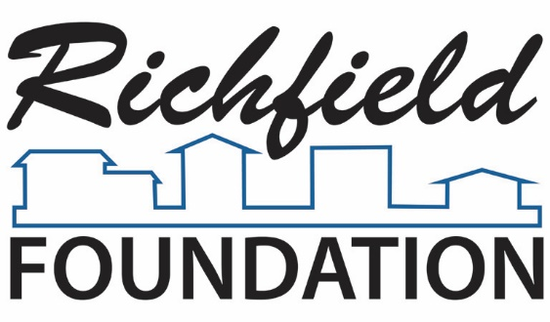
Chair
Husniyah Bradley

Vice-Chair
Lindsay Crye
Secretary
Julie Baumeisiter
Treasurer
Jill Anderson

Board of Directors
Ken Boie
Kate Burghardt
Claire Plank Gahler
Lindsi Gish
County Commissioner
Debbie Goettel
Stephanie Hislop
Scott Hvizdos
Jeremy Mork
Susan Rosenberg
Joanna Schnedler
Richfield Mayor
Mary Supple
Chris Swanson

In 2014, the Richfield Foundation introduced a new Matching Grants opportunity, to match funds raised by smaller community-based groups running projects that benefit Richfield.
In 2023, Matching Grant applications will be accepted April 15 through July 31, or until the budgeted funds are all approved. Decisions will be made by the Foundation Grant Committee, usually within one month. Grants will be awarded in amounts up to $500.
The Matching Grants are separate from our Annual Grant-making process. Annual Grant applications will be due in the fall and decisions made in November. It is highly unlikely that a group would get grants from both sources in the same year.
Both grant opportunities support the priorities of the Richfield Foundation: Successful Kids – Secure Families – Strong Community
More information about the Richfield Foundation is available at: www.richfieldfoundationmn.org
If you wish to apply for funds from the Foundation, please fill out the application and send it to: info@richfieldfoundationmn.org.
If you have any questions about the grant process, do not hesitate to call me at 612-203-9138 (cell).
Thank You,
Susan Rosenberg
Chair of the Grants Committee
Richfield Foundation

Who Should Apply for a Matching Grant?
This is designed for smaller organizations, which rely heavily on volunteers to carry out their work. It has a smaller maximum amount than the Annual Grant making process, but is available more of the year and has a shorter application.
Every proposal must meet the criteria of primarily benefiting people in Richfield and fit our three stated priorities: Successful Kids-Secure Families-Strong Community. Whether athletics, arts, academics, basic human needs, etc., projects should also fit the Foundation’s goal of making it easier for people to participate fully in life in Richfield.
Notes on eligibility:
- Your group is not required to be a registered 501(c)3 nonprofit organization (the usual formal nonprofit in the US), but your work must be the type of work such groups do.
- An applicant can be part of a faith community, but the proposed work should be for broader community benefit, not mainly religious purposes.
- We will not support work that includes lobbying, political campaigns, or partisan political activity.
- We will not fund applications that primarily benefit an individual or household.
The Matching Requirement
We hope these grants will increase the impact of your grassroots fundraising efforts. An important part of your application is the description of the fundraising efforts to be matched:
- The match will be dollar-for-dollar, up to $500, for all the funds you raise in the fundraising described in your application.
- You can apply before you complete the fundraising, so you can use the match as an incentive to your supporters. If so, please include an estimate of how much you think you can raise from the fundraising you describe. This will give us time to let you know if you will qualify for the match. After your fundraising is complete, we will work with you to confirm the exact amount.
- Or you can apply after your fundraising effort is complete. Please submit your application within one month after your fundraising is complete, and let your supporters know about the Foundation’s contribution.
- All funds you raise will be taken into consideration when determining matching grants, but groups are encouraged to hold events that boost small donations such as car-washes or individual appeals.
Thank you very much for your hard work in making Richfield better and your interest in working with the Richfield Foundation.

1. Organization: _________________________________________________________________
Website (if applicable): __________________________________________________________
Address: _____________________________________________________________________
Phone: ______________________________________________________________________
2. IRS Tax Exempt Number (if a registered 501c3):______________________________________
You are not required to be a 501c3 nonprofit, but must use the funds in a manner that matches that of a 501c3.
3. Contact Person (name and title): _________________________________________________
Email: _______________________________________________________________________
Address (if differs from above): ___________________________________________________
Phone: ______________________________________________________________________

4. Project Leader (name and title) : _________________________________________________
Email: _______________________________________________________________________
Address: _____________________________________________________________________
Phone: ______________________________________________________________________

5. Name of Project: _________________________ Requested Amount: _____________________

6. Describe how you plan to use the funds you raise, including a description of who will benefit from the activity. Your work should primarily support Richfield residents, and increase opportunity for people to participate in community life.
____________________________________________________________________________
____________________________________________________________________________
____________________________________________________________________________
____________________________________________________________________________

7. Describe the funding source(s) you would like the Foundation to match. Include how much you have raised or expect to raise. If your application is approved, you will need to provide an accounting of the fundraising, so we know the exact matching amount to send you.
____________________________________________________________________________
____________________________________________________________________________
____________________________________________________________________________
____________________________________________________________________________
____________________________________________________________________________
____________________________________________________________________________
____________________________________________________________________________
____________________________________________________________________________

8. Provide any additional information on the organization or activity that would help us understand how your application fits our goals and meets the criteria of the matching grant program.
____________________________________________________________________________
____________________________________________________________________________
____________________________________________________________________________
____________________________________________________________________________
____________________________________________________________________________
____________________________________________________________________________
____________________________________________________________________________
____________________________________________________________________________

Thank you for your interest in the Richfield Foundation Matching Grant.
Applications are accepted April 1 to July 31, 2023.
Please email completed application to info@richfieldfoundationmn.org

